# Assignment Name/Description

Create a simple banking system dealing in 2 types of account, current and savings. Each account holder can perform debit and credit operations in sequentially. Each operation for each member must be atomic. You need to design your application with 5 account holders, and the user is asked to debit or credit from a particular account. On completion of all the operation your application must display the account summary of every customer account.

# Output

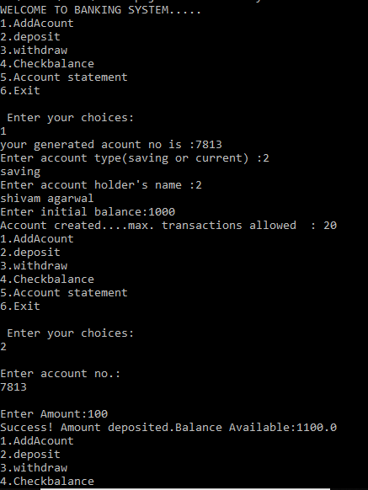

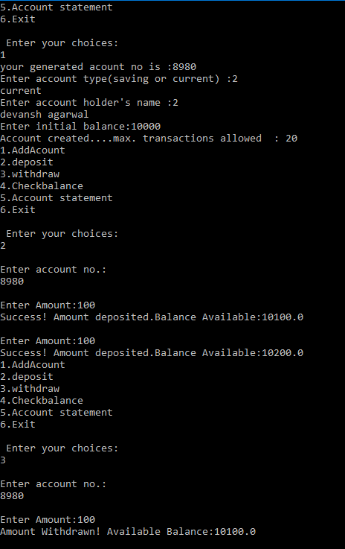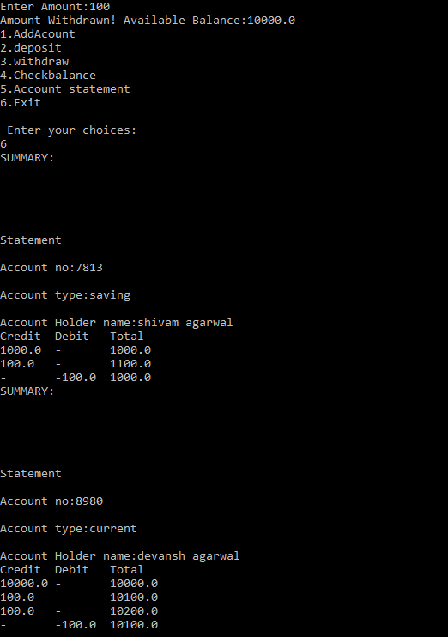

# Source code

[Task Source Code](https://drive.google.com/open?id=15wvmXKw3y30ab-DibHUGDvm8wxHKIi6A)